**Exercise 4**

**Mariyum Bashir**

(a)

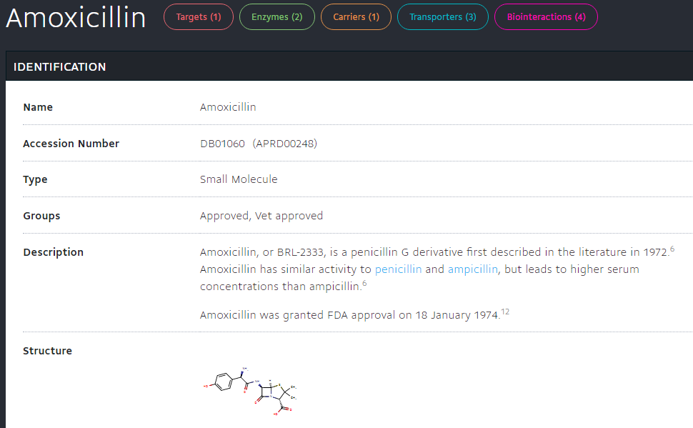

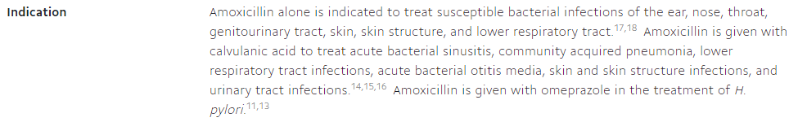

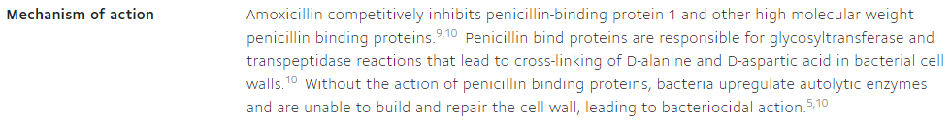

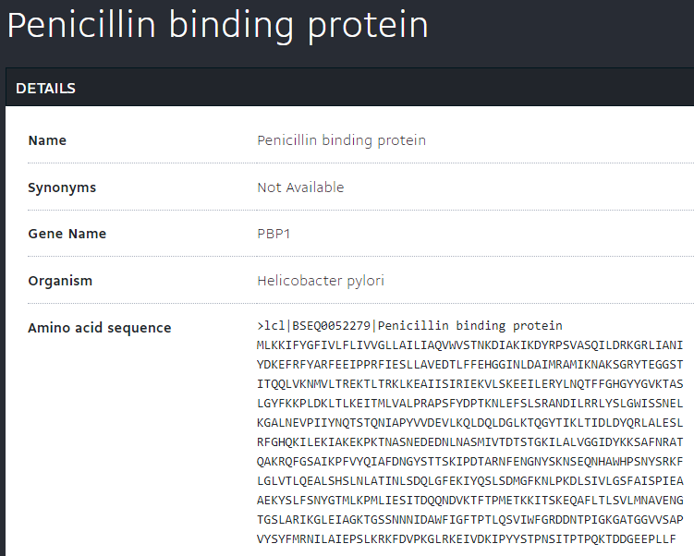

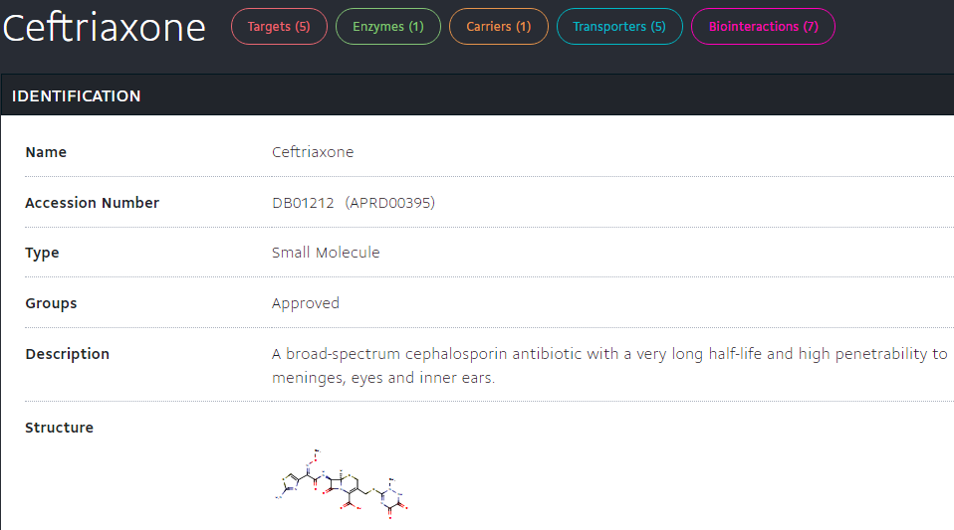



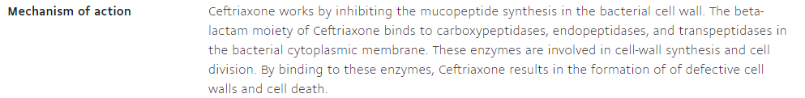

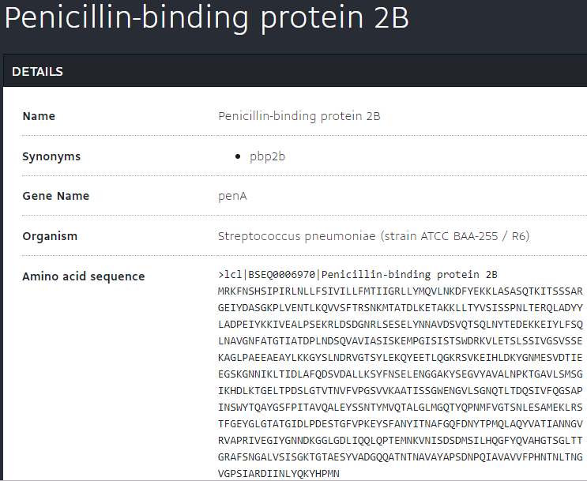

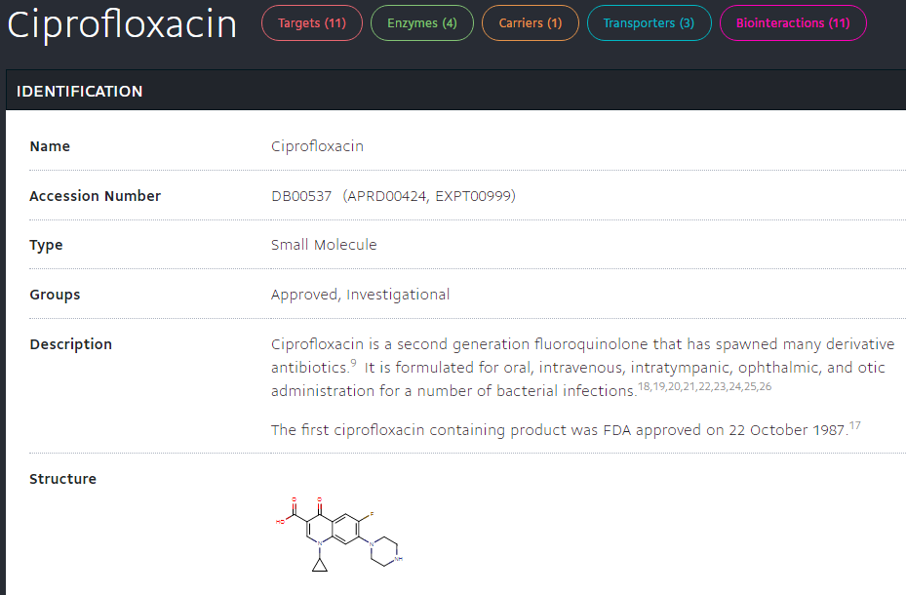

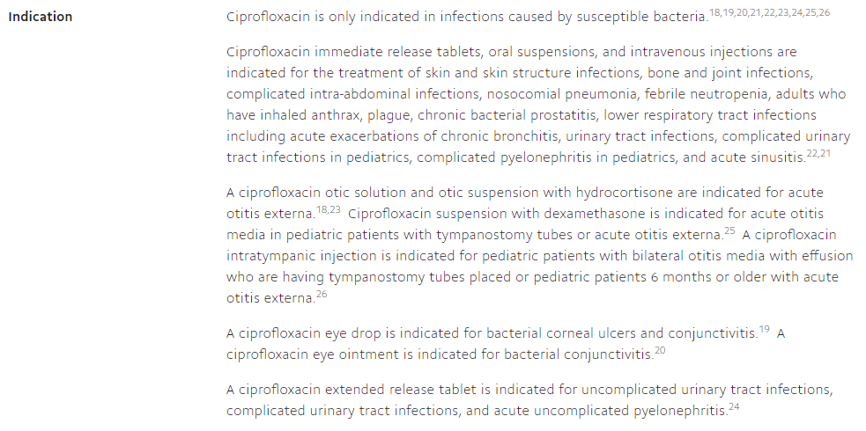



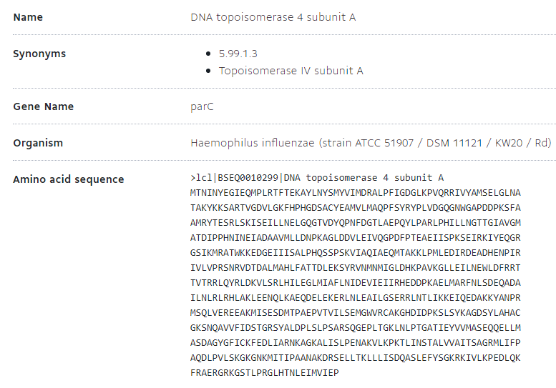

(b)

Clindamycin  
>lcl|BSEQ0052277|50S ribosomal protein L1

MAKKGKKYQEAASKVDRTQHYSVEEAIKLAKETSIANFDASVEVAFRLGIDTRKNDQQIR

GAVVLPNGTGKSQSVLVFAKGDKIAEAEAAGADYVGEAEYVQKIQQGWFDFDVVVATPDM

MGEVGKLGRVLGPKGLMPNPKTGTVTMDVKKAVEEIKAGKVEYRAEKAGIVHASIGKVSF

TDEQLIENFNTLQDVLAKAKPSSAKGTYFKSVAVTTTMGPGVKIDTASFK

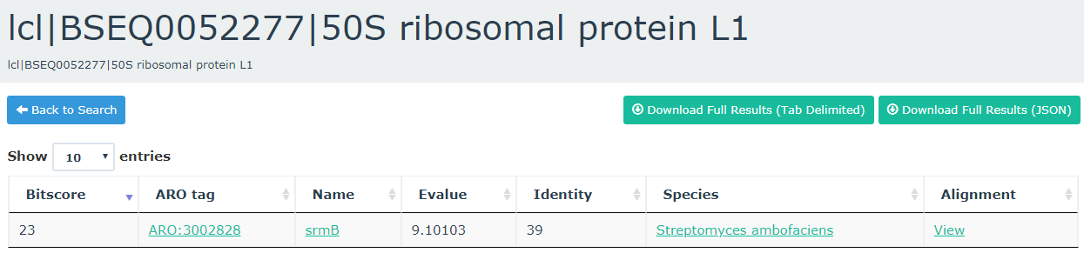

Azithromycin

>lcl|BSEQ0052173|23S rRNA

GGUUAAGCGACUAAGCGUACACGGUGGAUGCCCUGGCAGUCAGAGGCGAUGAAGGACGUG

CUAAUCUGCGAUAAGCGUCGGUAAGGUGAUAUGAACCGUUAUAACCGGCGAUUUCCGAAU

GGGGAAACCCAGUGUGUUUCGACACACUAUCAUUAACUGAAUCCAUAGGUUAAUGAGGCG

AACCGGGGGAACUGAAACAUCUAAGUACCCCGAGGAAAAGAAAUCAACCGAGAUUCCCCC

AGUAGCGGCGAGCGAACGGGGAGGAGCCCAGAGCCUGAAUCAGUGUGUGUGUUAGUGGAA

GCGUCUGGAAAGGCGCGCGAUACAGGGUGACAGCCCCGUACACAAAAAUGCACAUGCUGU

GAGCUCGAUGAGUAGGGCGGGACACGUGGUAUCCUGUCUGAAUAUGGGGGGACCAUCCUC

CAAGGCUAAAUACUCCUGACUGACCGAUAGUGAACCAGUACCGUGAGGGAAAGGCGAAAA

GAACCCCGGCGAGGGGAGUGAAAAAGAACCUGAAACCGUGUACGUACAAGCAGUGGGAGC

AUGCUUAGGCGUGUGACUGCGUACCUUUUGUAUAAUGGGUCAGCGACUUAUAUUCUGUAG

CAAGGUUAACCGAAUAGGGGAGCCGAAGGGAAACCGAGUCUUAACUGGGCGUUAAGUUGC

AGGGUAUAGACCCGAAACCCGGUGAUCUAGCCAUGGGCAGGUUGAAGGUUGGGUAACACU

AACUGGAGGACCGAACCGACUAAUGUUGAAAAAUUAGCGGAUGACUUGUGGCUGGGGGUG

AAAGGCCAAUCAAACCGGGAGAUAGCUGGUUCUCCCCGAAAGCUAUUUAGGUAGCGCCUC

GUGAACUCAUCUCCGGGGGUAGAGCACUGUUUCGGCAAGGGGGUCAUCCCGACUUACCAA

CCCGAUGCAAACUGCGAAUACCGGAGAAUGUUAUCACGGGAGACACACGGCGGGUGCUAA

CGUCCGUCGUGAAGAGGGAAACAACCCAGACCGCCAGCUAAGGUCCCAAAGUCAUGGUUA

AGUGGGAAACGAUGUGGGAAGGCCCAGACAGCCAGGAUGUUGGCUUAGAAGCAGCCAUCA

UUUAAAGAAAGCGUAAUAGCUCACUGGUCGAGUCGGCCUGCGCGGAAGAUGUAACGGGGC

UAAACCAUGCACCGAAGCUGCGGCAGCGACGCUUAUGCGUUGUUGGGUAGGGGAGCGUUC

UGUAAGCCUGUGAAGGUGUACUGUGAGGUAUGCUGGAGGUAUCAGAAGUGCGAAUGCUGA

CAUAAGUAACGAUAAAGCGGGUGAAAAGCCCGCUCGCCGGAAGACCAAGGGUUCCUGUCC

AACGUUAAUCGGGGCAGGGUGAGUCGACCCCUAAGGCGAGGCCGAAAGGCGUAGUCGAUG

GGAAACAGGUUAAUAUUCCUGUACUUGGUGUUACUGCGAAGGGGGGACGGAGAAGGCUAU

GUUGGCCGGGCGACGGUUGUCCCGGUUUAAGCGUGUAGGCUGGUUUUCCAGGCAAAUCCG

GAAAAUCAAGGCUGAGGCGUGAUGACGAGGCACUACGGUGCUGAAGCAACAAAUGCCCUG

CUUCCAGGAAAAGCCUCUAAGCAUCAGGUAACAUCAAAUCGUACCCCAAACCGACACAGG

UGGUCAGGUAGAGAAUACCAAGGCGCUUGAGAGAACUCGGGUGAAGGAACUAGGCAAAAU

GGUGCCGUAACUUCGGGAGAAGGCACGCUGAUAUGUAGGUGAAGCGACUUGCUCGUGGAG

CUGAAAUCAGUCGAAGAUACCAGCUGGCUGCAACUGUUUAUUAAAAACACAGCACUGUGC

AAACACGAAAGUGGACGUAUACGGUGUGACGCCUGCCCGGUGCCGGAAGGUUAAUUGAUG

GGGUUAGCGCAAGCGAAGCUCUUGAUCGAAGCCCCGGUAAACGGCGGCCGUAACUAUAAC

GGUCCUAAGGUAGCGAAAUUCCUUGUCGGGUAAGUUCCGACCUGCACGAAUGGCGUAAUG

AUGGCCAGGCUGUCUCCACCCGAGACUCAGUGAAAUUGAACUCGCUGUGAAGAUGCAGUG

UACCCGCGGCAAGACGGAAAGACCCCGUGAACCUUUACUAUAGCUUGACACUGAACAUUG

AGCCUUGAUGUGUAGGAUAGGUGGGAGGCUUUGAAGUGUGGACGCCAGUCUGCAUGGAGC

CGACCUUGAAAUACCACCCUUUAAUGUUUGAUGUUCUAACGUUGACCCGUAAUCCGGGUU

GCGGACAGUGUCUGGUGGGUAGUUUGACUGGGGCGGUCUCCUCCUAAAGAGUAACGGAGG

AGCACGAAGGUUGGCUAAUCCUGGUCGGACAUCAGGAGGUUAGUGCAAUGGCAUAAGCCA

GCUUGACUGCGAGCGUGACGGCGCGAGCAGGUGCGAAAGCAGGUCAUAGUGAUCCGGUGG

UUCUGAAUGGAAGGGCCAUCGCUCAACGGAUAAAAGGUACUCCGGGGAUAACAGGCUGAU

ACCGCCCAAGAGUUCAUAUCGACGGCGGUGUUUGGCACCUCGAUGUCGGCUCAUCACAUC

CUGGGGCUGAAGUAGGUCCCAAGGGUAUGGCUGUUCGCCAUUUAAAGUGGUACGCGAGCU

GGGUUUAGAACGUCGUGAGACAGUUCGGUCCCUAUCUGCCGUGGGCGCUGGAGAACUGAG

GGGGGCUGCUCCUAGUACGAGAGGACCGGAGUGGACGCAUCACUGGUGUUCGGGUUGUCA

UGCCAAUGGCACUGCCCGGUAGCUAAAUGCGGAAGAGAUAAGUGCUGAAAGCAUCUAAGC

ACGAAACUUGCCCCGAGAUGAGUUCUCCCUGACUCCUUGAGAGUCCUGAAGGAACGUUGA

AGACGACGACGUUGAUAGGCCGGGUGUGUAAGCGCAGCGAUGCGUUGAGCUAACCGGUAC

UAAUGAACCGUGAGGCUUAACCUU



**TASK BRUFEN**

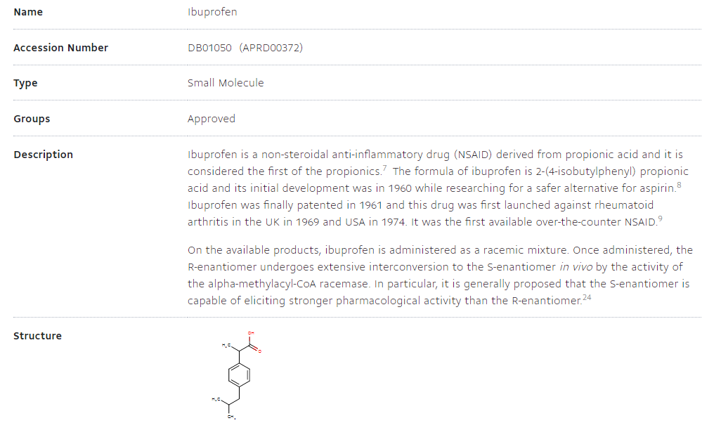

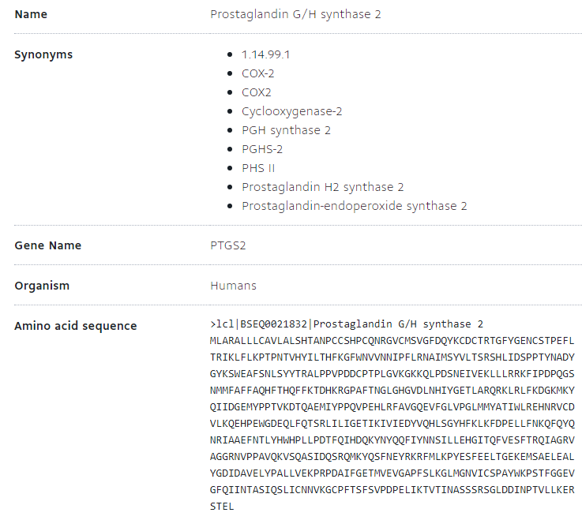

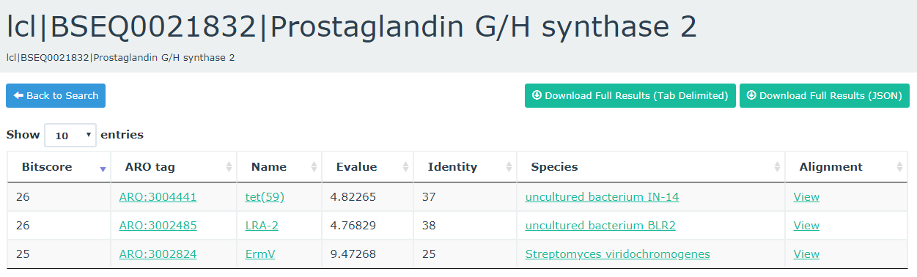

**TASK RGI**

